|  |
| --- |
| Motorcycle |
| Brand: String  Colour: String  Model: String |
| disTravel(): void  sport(String type): void  cruising(): void |

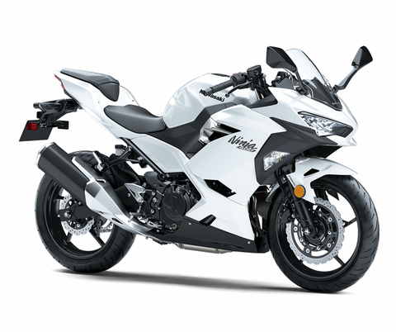

state

method

|  |
| --- |
| Computer |
| Brand: String  Type: String  ScreenResolt: String |
| edu(): void  banking(int accNo, double accBal): void  work(): void  entertain(): void |

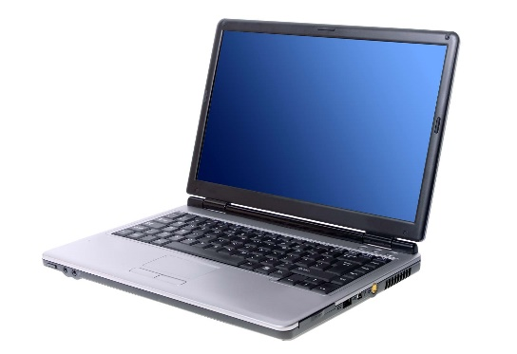

method

state

|  |
| --- |
| Phone |
| Brand: String  Type: String  OperatingSys: String |
| edu(): void  banking(int accNo, double accBal): void  work(): void  entertain(): void |

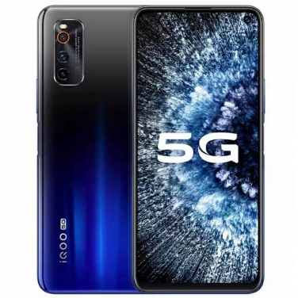

state

method

|  |
| --- |
| Pressure cooker |
| Brand: String  Colour: String  Model: String  Type: String |
| cookRice(): void  heatFood(): void  cookSoup(): void |

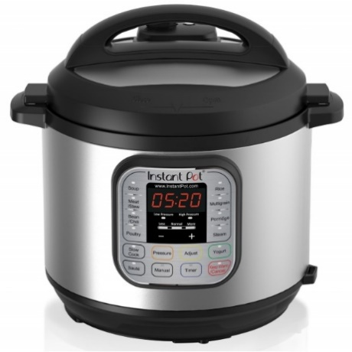

method

state

|  |
| --- |
| Bag |
| Brand: String  Colour: String  Size: double  Type: String |
| travel(): void  edu(): void  work(): void |

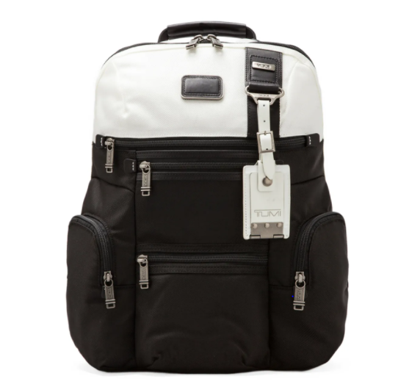

state

method